EXP: 10

1) Create a view with name 'v1' using employees1 table which holds the value of employee_id and salary of employee
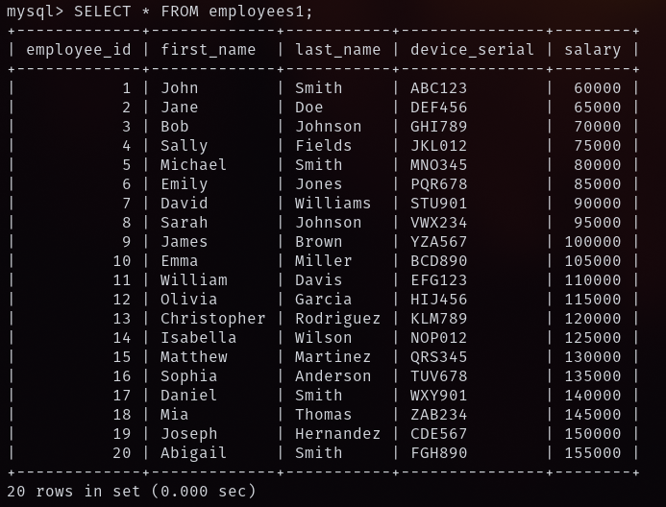
2) Do the insert and delete records from v1 table
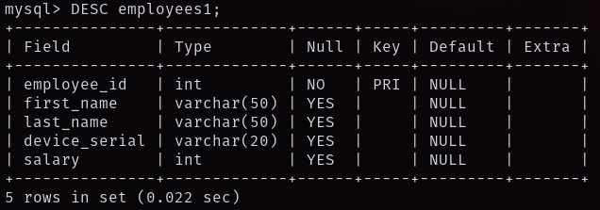
3) Create index1 for 'salary' attribute from employees1 relation and list the first name of the employees whose salary is above 145000 and explain the working principle of indexing and then drop the index1
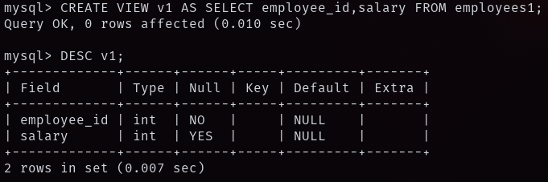
4) Create index1 for 'employee_id' attribute and display the first name of an employee whose employee id is 10 and explain the working principle of index1
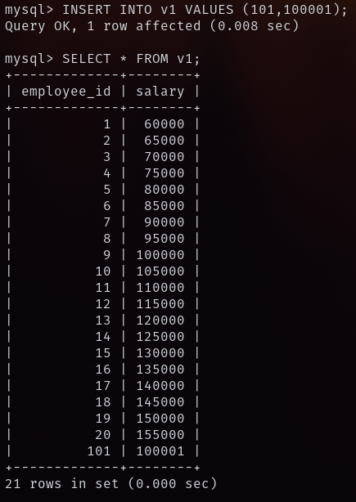
5) Create a view with name 'v1' using employees1 table which holds the value of employee_id and salary of employee (output)
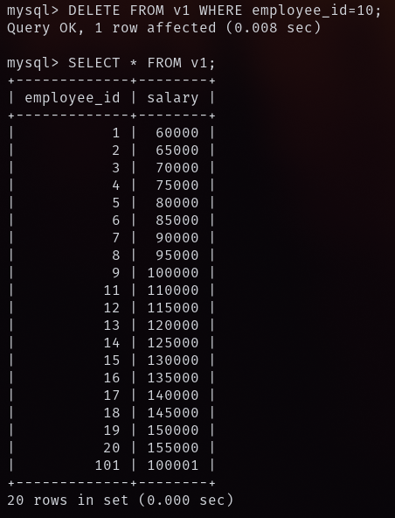
6) Do the insert and delete records from v1 table (output)
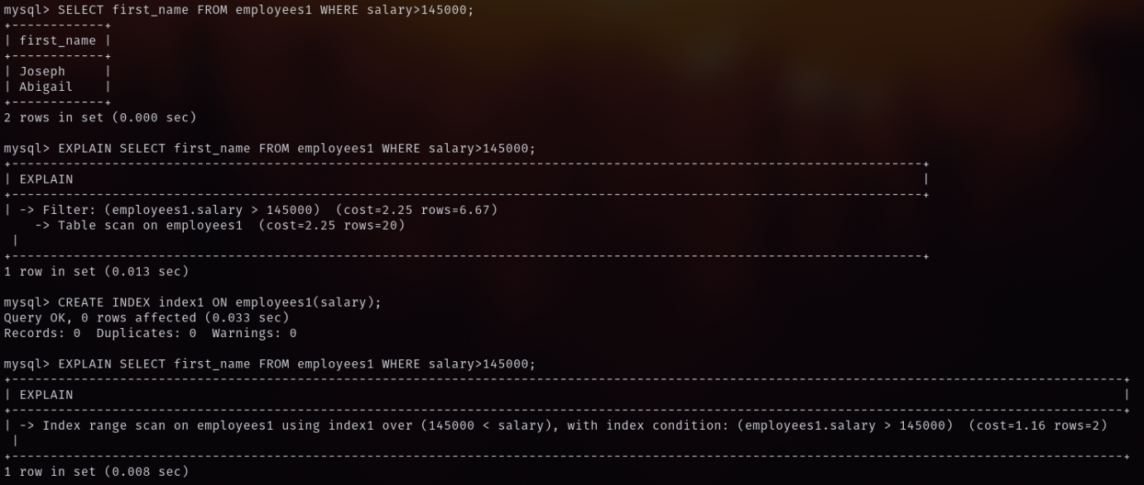
7) Create index1 for 'salary' attribute from employees1 relation and list the first name of the employees whose salary is above 145000 and explain the working principle of indexing and then drop the index1 (output)
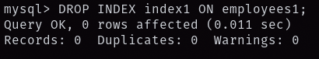
8) Create index1 for 'employee_id' attribute and display the first name of an employee whose employee id is 10 and explain the working principle of index1 (output)

